# RAP-004-RAP-Architecture Overview

<https://youtu.be/MUSDJ6jbOK4?list=PLqz8SLrkjv2iwPtPRJ4V6zJRfgNrgZKlQ>

<https://youtu.be/MUSDJ6jbOK4?list=PLqz8SLrkjv2iwPtPRJ4V6zJRfgNrgZKlQ>

## What is business service provisioning and Service Consumption:

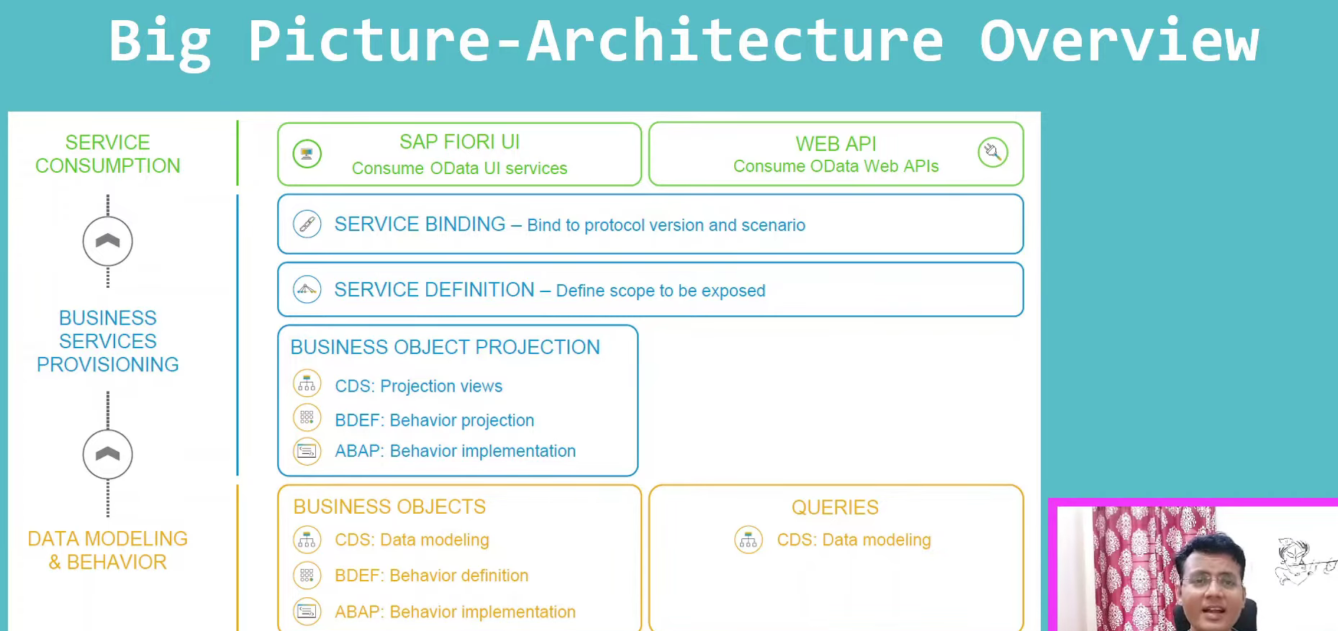

* Expose the business objects in business service provisioning.

## What is business service?

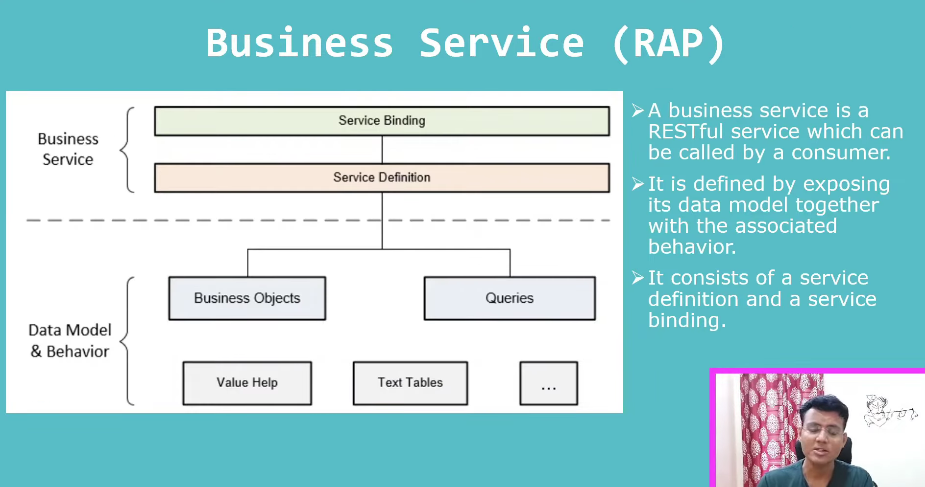

* Business service act as a service provider and consumer.
* When RAP prospective, Business service act as a service provider, because it is creating the data model along with the behavior is one service and that is providing to the consumer, it will consume it any where either in fiori apps or any other language that can consumed.
* Business service has two parts.
  + Service definition.
  + Service binding.

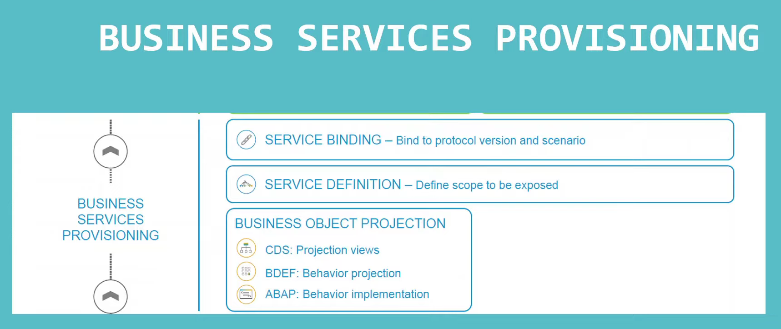

Provisioning means, what can be exposed to outer world., we can’t directly consumed at outer world.

* Business object is the base object.
* On top of the business object, we can create multiple business services also.
* To create the business services, we have to create the middle layer it is called as business service provisioning.
* Business service provisioning: here what need to project to out side the world.
* Business service provisioning has divided into 3 parts.
  + Business object provisioning.
  + Service definition.
  + Service Binding.

### Business Object Projection:

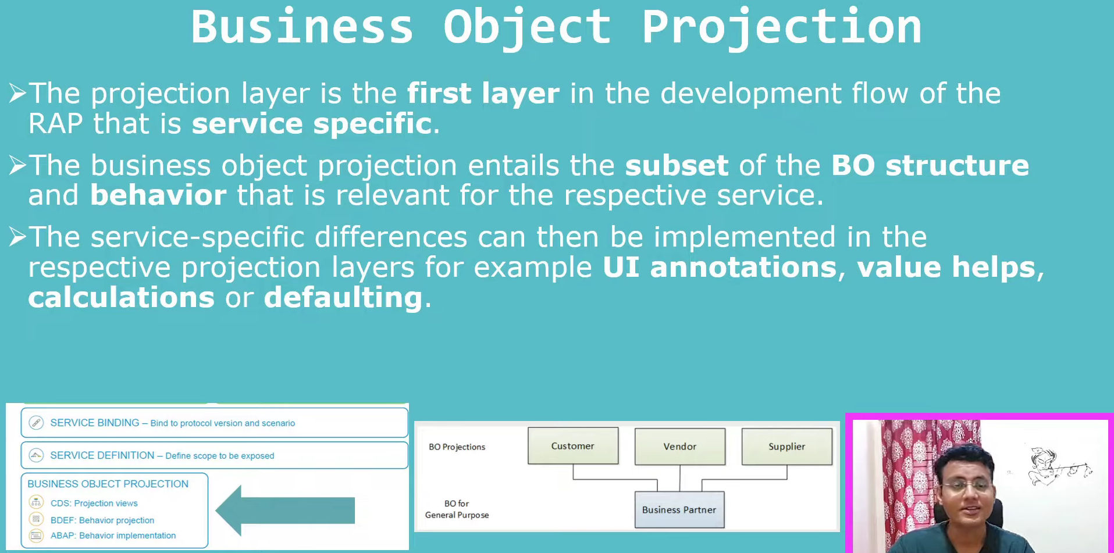

* This is the first layer, where we are defining the service specifically.
* In first step we created the business object, that is not specific to the service, and this BO, we can use it in multiple services.

Example:

* on Business partner: have the Customer/Vendor/Supplier,Business partner can have lot of common business functionalities in SAP, BP can act as customer as well, vendor as well and supplier also.
* Business partner is our base view. It will have the lot of common things along with the distinct things, those all things defined in base view. On top of base view we will create the projection views.

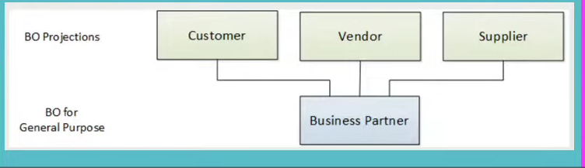

Example:

* Suppose I want to create the service, where I can create/delete/modify the customer, that kind of application I can create. For this I can project business partner view as a customer. And I can only the customer specific thing on the specific BO to create/delete/modify for this customer. After some time that requirement changed now we want to create the vendor object/applications where we want to create/delete/modify the vendors- what we will do in this case instead of creating again separate BO because we know lot of the fields in the customer and vendors are common. and one customer can act as vendor as well. Here what we will do vendor specific thing in the business partner itself then along with other fields we will project their in the vendor. That is why we have the one base view, this is never act as service specific, but the customer and vendor projected views are the service specific we are going to create for create/update/delete of the particular customer and vendor. This will be the different/different services.
* So, it is part of the object projection, project the structure and behavior from the base view to the projected view.

Whatever we want to consumed, we want to consume out of the particular business partner and business partner is the wider thing and it has more fields. Suppose in business partner has 1000 fields- 500 fields are common, 100- customer specific, 100-vendor specific, 100- supplier specific and other fields also there. So here we will create the projection view with 500 common fields with 100- specific customer fields. Same way behavior also.. customer to do the c/u/d operations and while coming to the vendor service we can use the update/read only.

Not only that we can change the user interface also every specific services.to visibility differently for customer and vendor.

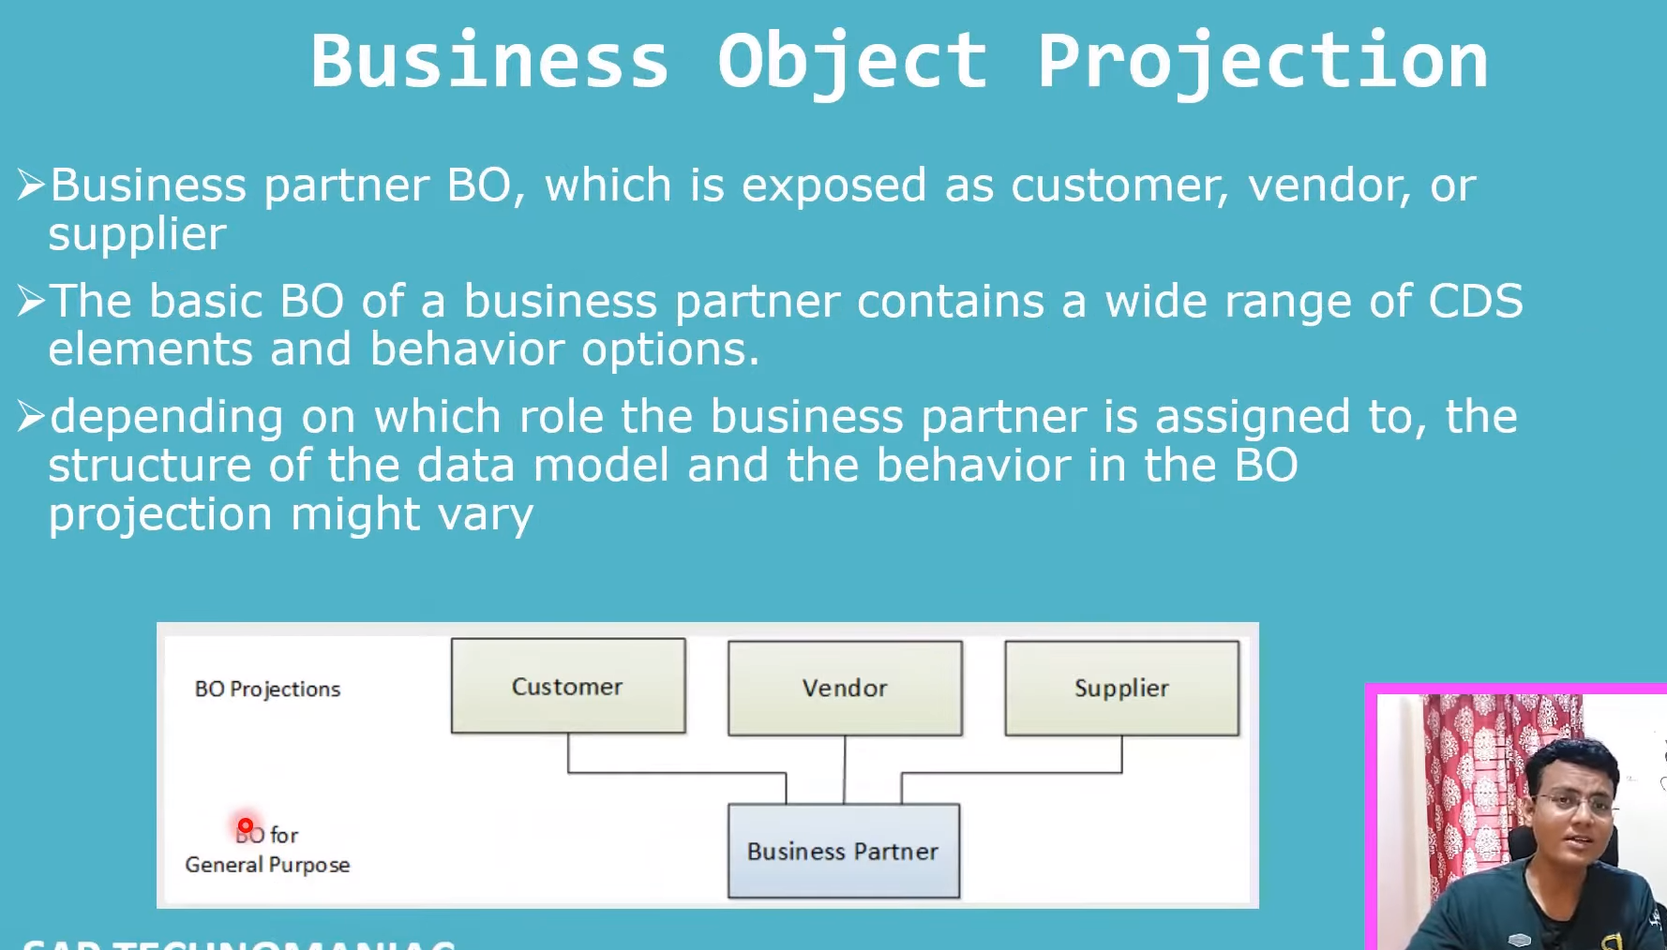

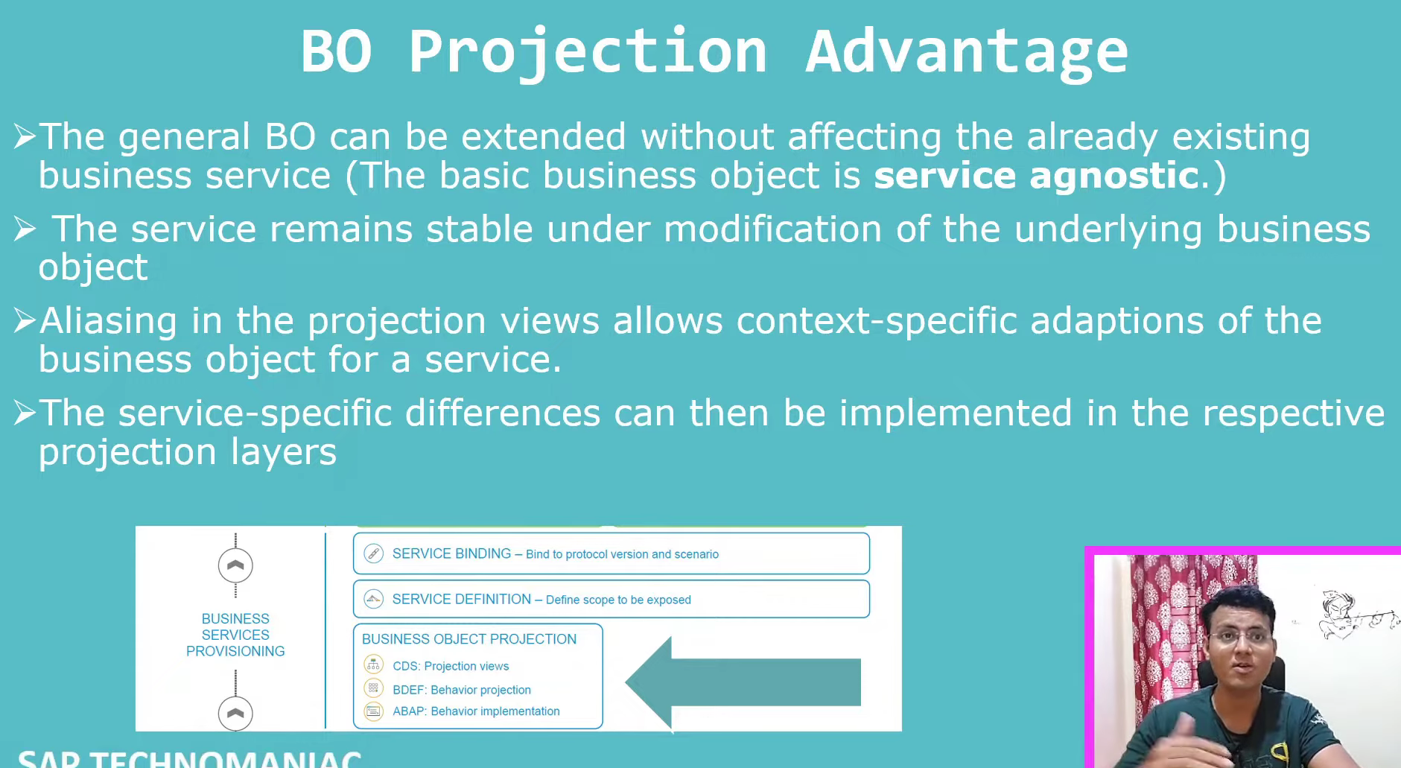

### Business Object projection-artifacts:

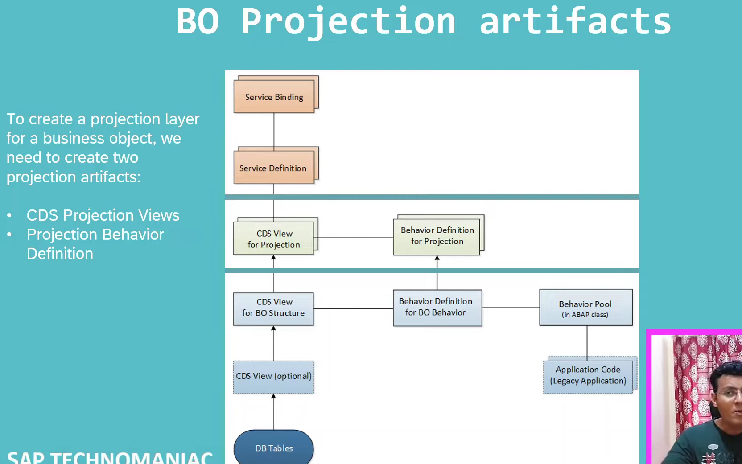

1. CDS Projection Views.
2. Projection behavior definitions.

#### CDS Projection View:

It is defining, what all are the fields need to consume from base view, what all are the entities available in base view, those all entities are creates the projection.

Ex- base view we have the Travel, Booking and Booking Supplements then we have to create the projection for the Travel, Booking and Booking Supplement- 3- projection view will be created on top of the base views. Projection view will define what all are the fields required from base view and base view has more fields are available and while coming to the projection less number of fields are equals to the base number of fields.

#### Behavior Definition for Projection:

Need to define what behavior we want to consumed in part of the service. In base all things are available. their might be the create/update/delete/read everything available. But you want to do the read and modify in your service then you have to define read and modify operations only in behavior definitions.

Behavior definitions is link to the behavior pool means you have the different classes but behavior projection not linked to the classes. we can’t do the implementation on the behavior projection.

### Service Definition:

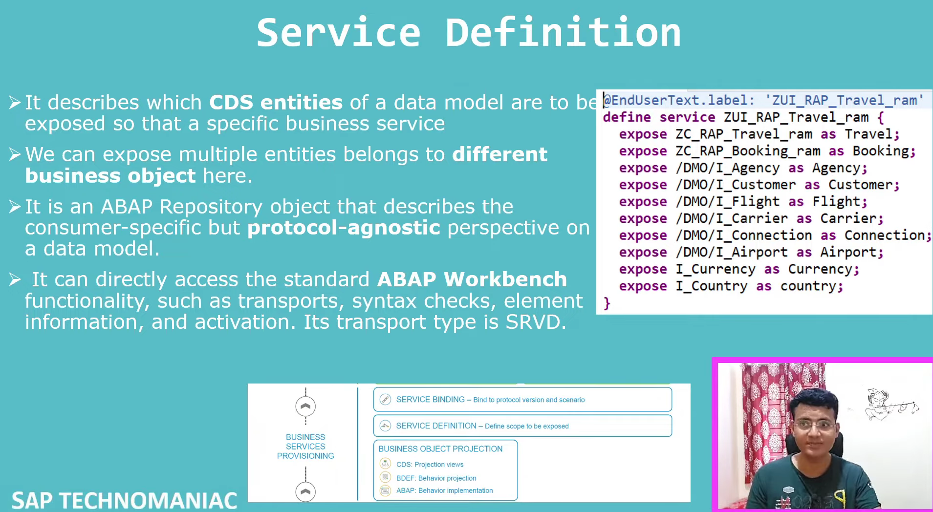

Service definition we can’t create the protocol.

### Service Binding:

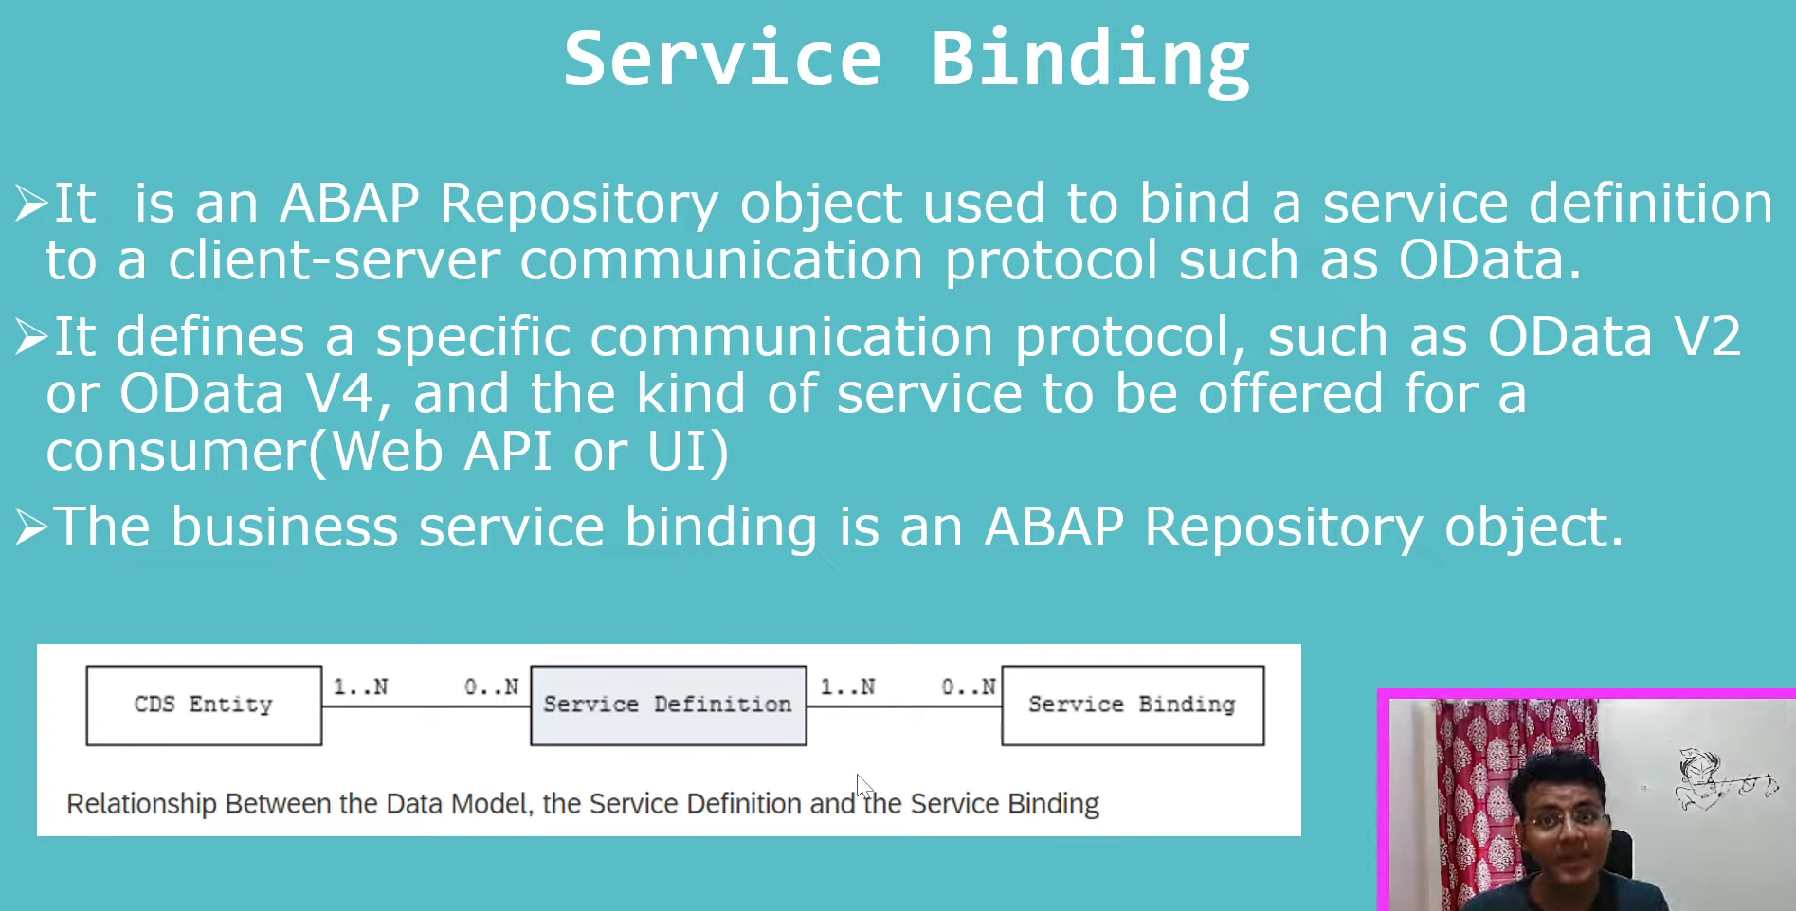

Service binding/Service definitions are ABAP repository object.

### Service Consumption

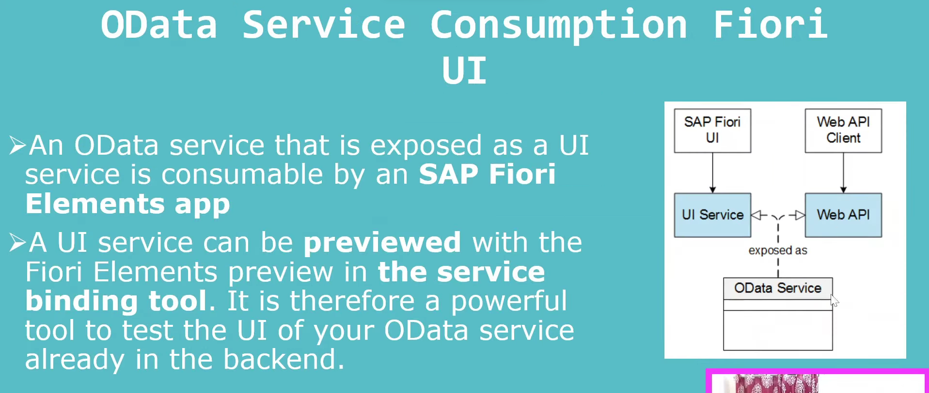

SAP Fiori Elements app- > Exposed in a UI service. Not in web api.

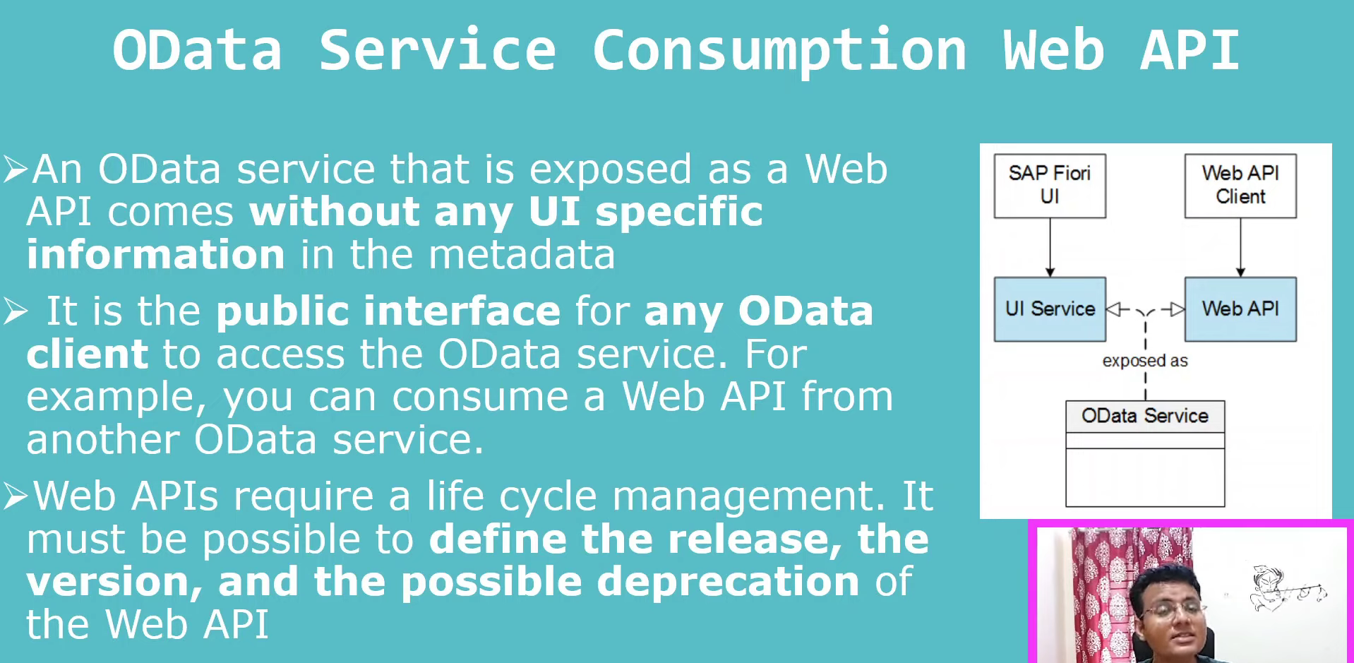

SAP Fiori is a set of **design guidelines** for the user interface (UI), while a Web API (like OData services) is the **back-end communication layer** that provides data to the UI. They serve entirely different purposes within a complete application architecture.

* **SAP Fiori UI:** This is the front-end, visible part of the application that the user interacts with. It provides a modern, role-based, and responsive user experience based on SAP's design principles.
* **Web API (OData):** This is the underlying back-end service that the Fiori UI consumes. It handles data requests, logic, and integration with the core SAP system (e.g., S/4HANA), but has no visual component itself.